Course application guide for exchange studies at Mid Sweden University
Sweden has a unique coordinated admissions system. This means that you will select courses from Mid Sweden University’s website but your full application will be managed through a national website: www.universityadmission.se. Please read the complete guide before proceeding with your application.

Document overview

- Create user account at universityadmission.se
- Use the application link to select courses
- Selected courses
- Log in to your University Admissions account
- Application
- Review & submit course selection
- Complete application by uploading supporting documentation
- General information & admission results

Step 1: Create user account at University Admissions

Please go to http://www.universityadmissions.se to create a user account. It is important that you register an email account that you check regularly, to ensure that you do not miss any important information. Once you are registered and the application is complete, you will be able to see and follow your application on “my pages”

- Choose the tab “Log in”
- Click “Create account”
- Click “NO I don’t have a Swedish personal ID number (personnummer)” and follow the instructions.

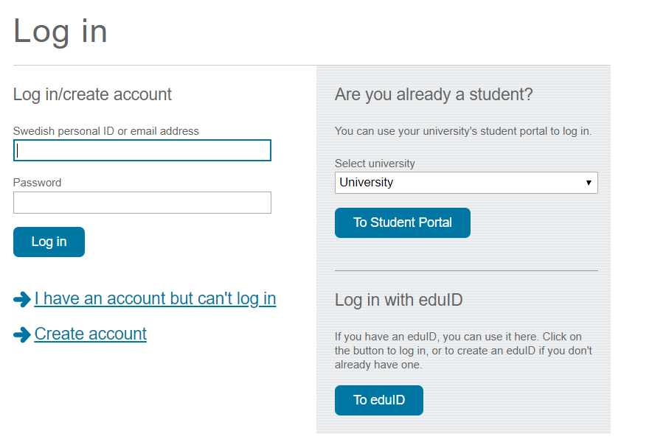

Step 2: Use the application link to select courses
Once your exchange nomination is accepted by Mid Sweden University, you will receive an email welcoming you to submit your exchange application. The email contains a personal application link directing you to the page below:

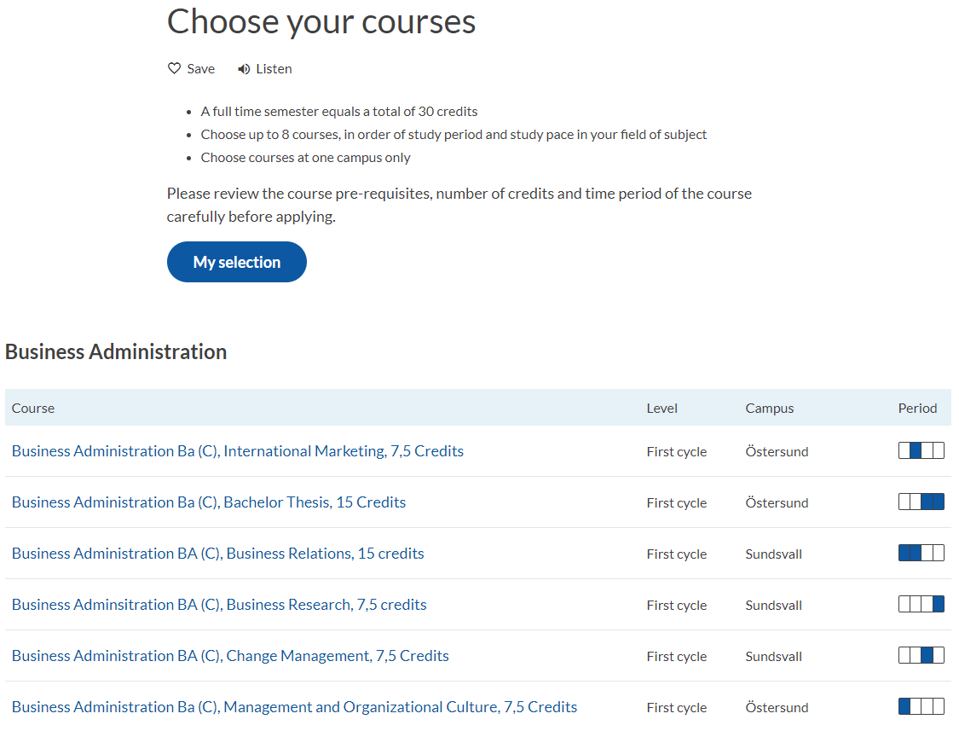

Important to consider when choosing courses:
Course load : Full-time studies at Mid Sweden University is 30 credits (30 ECTS) per semester. You may enroll in courses of a total of 30 credits during one semester. The exception is the Swedish Language course, which you may enroll in on top of a full course load since this course is pre-university level.
Study period: When choosing courses, please note which period the course is given and the study pace, to avoid schedule clashes. Our semester is divided into four periods of 5 weeks each. You should aim to have a study pace of 100% for the whole semester. Full-time courses are usually taken one after the other (consecutive scheduling) alternately, if the courses are part time, two courses may be taken during the same period (parallel scheduling).
Pace of study: Courses are given at different study pace. Full-time studies (100 %) equals approximately 40 hours a week. Some courses are given at half time (50 %) or part-time (25 %), which means that the work load is approximately 20 hours and 10 hours per week. Therefore, half-time and part-time courses run for a longer period than a full-time course.
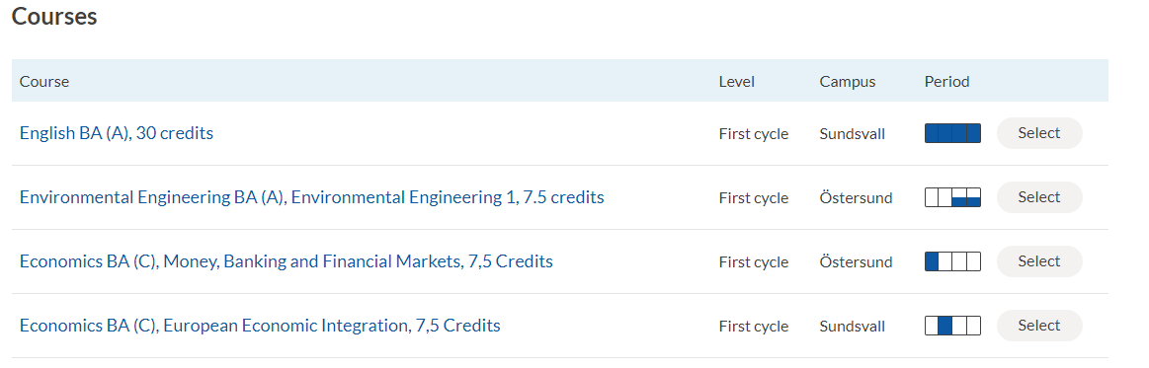
Please note the errors in the image below. In this example, the student has chosen courses across both campuses and not taken study pace or study period into consideration when choosing courses (read study information guide to exchange student before submitting your course application) This is an example of a course selection which would not be approved:

Step 3: Selected courses

Click “My selection” to get an overview of your chosen courses. Please double check that you have
a suitable course combination in terms of study pace, study period and campus location.

When you are satisfied with your course selection, click “Apply”. Once you do this, you’ll be redirected to University Admissions and you will not be able to go back and add any more courses to your course selection. If you haven’t created an account yet on University Admissions, it’s time to do so now (see step 1).
Important: Make sure that you use the same e-mail address as these instructions were sent to. We
will communicate with you through this email address during the application process.
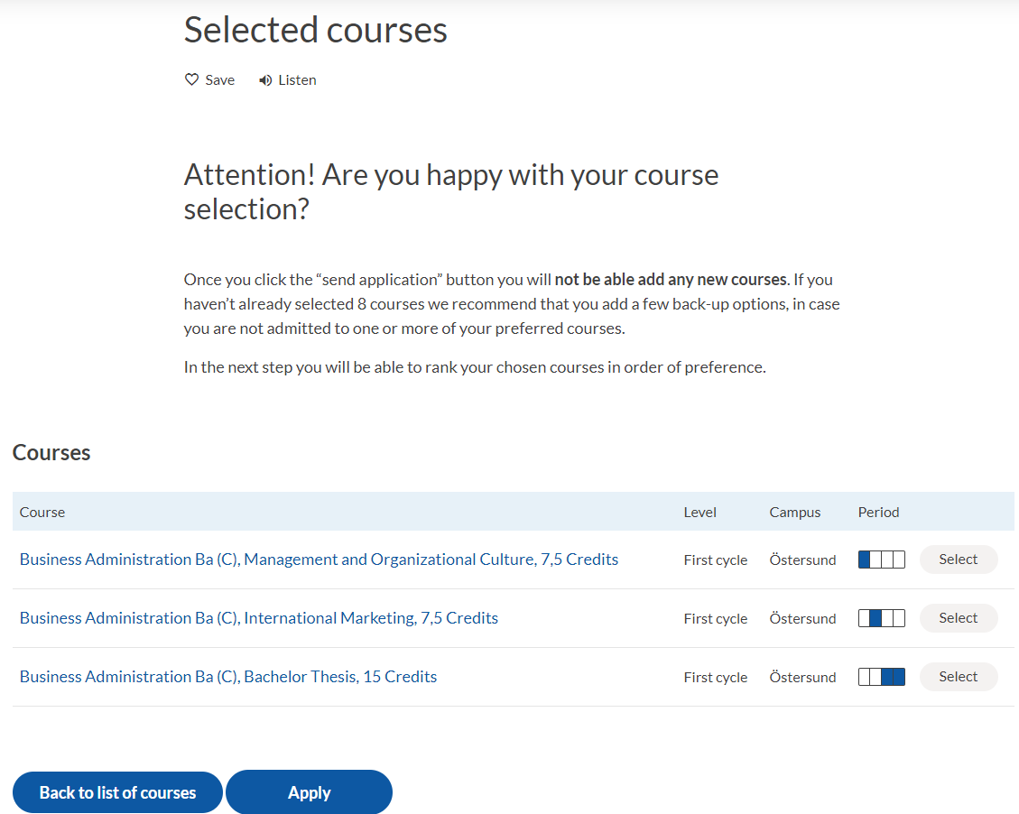

Step 4: Log in to your University Admissions account

- Log in to your University Admissions account (step 1)

Step 5: Application
When you log in to your account on University Admissions, you will see your course selection as shown in the picture below.
You must rank the courses before submitting your application:
List the courses in order of preference. You can apply for a maximum of eight courses but since you will not be admitted to more than 30 credits per term, it is very important how you prioritise your courses. Rank your courses in order of preference using the arrows on the right. Here you can also remove any courses you no longer want to apply for (click the red x on the right to remove a course). You are not able to add course at this stage.
Press “continue” when you have ranked your courses and want to proceed with the application.
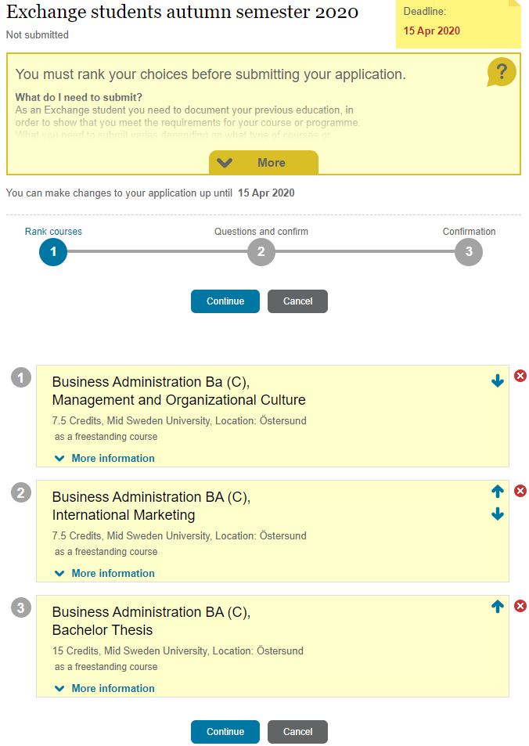
If you have any problems with your course selection at this stage, contact incomingstudents@miun.se

Step 6: Review & submit course selection
You will have one final chance to review your course selection before you submit it.

- You will receive the below confirmation once your course selection is submitted successfully.
- Please press OK to continue to upload your supporting documents and complete your application.
- In the Application tab you can view your submitted course application. This is also where you will access your letter of admission (Notification of Selection Results) You may download it as a pdf. Please note that your letter of admission will not be emailed or posted to you.
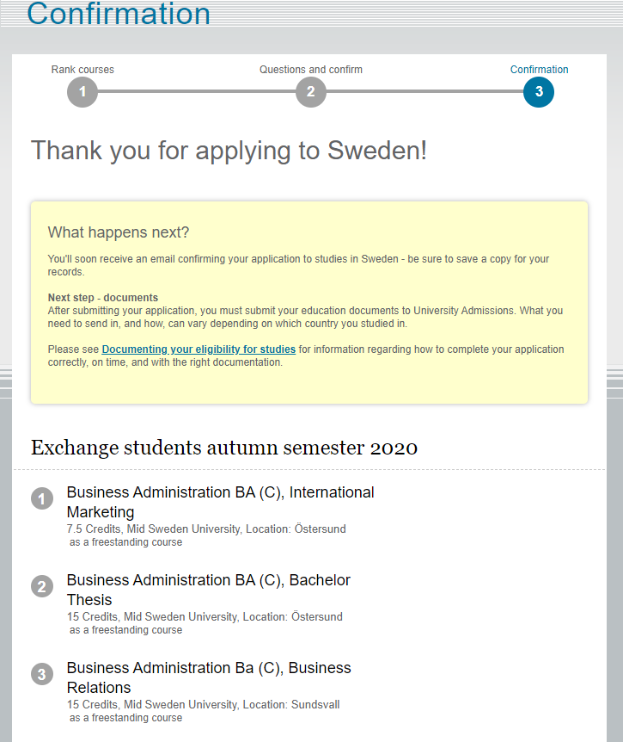

Step 7: Upload supporting documentation
Upload your documents under the documents tab on University Admissions after you have submitted your course selection. Please upload the documents listed below:
- Transcript of records of all previous university studies (this includes transcript from bachelor studies if you are a masters student). Please ensure the transcripts have been translated into English.

- A copy of your passport or photo ID

- Study Information: Name the courses that you are going to complete at your home University before you arrive at Mid Sweden University. We need to know all the courses that does not yet appear on your transcript. Include course name and credits.
Please note that English language test results are not required for partner students nominated for exchange studies.
Preparing your documents:
It's important that you prepare your documents correctly - and that you have the right documents before you begin uploading. Please prepare them as follows:

- Please scan your original documents (not copies). If the document is in colour, please scan it in colour.
- All files must be in PDF-format.
- Remember to include all pages of documents that contain any type of text/writing, even if it is on a back page.
- Scan documents that are in the same category (i.e. transcripts and diploma copies) into ONE file - do not make a separate file for each page.
- Check your scan to ensure that everything on the original document is readable, including text, stamps, numbers, etc.
- If you can't get a clearly legible scan, we suggest you submit your documents via regular mail to the International Relations Office instead. Please contact us in this case. We do not recommend that applicants take photos of their documents, as we cannot guarantee that we can accept the document in that format.

Uploading your prepared files
Once your documents are scanned into PDF files, it is time to use the uploading function on Universityadmissions.se:
- Go to the documents tab.
- Follow the instructions and upload your documents accordingly.
- Tip: We recommend that you name the PDF files to reflect its content.
- Remember that once your documents are uploaded, you can't see them or delete them. You will be provided with the name you have given the file, and the file name for reference.
Last day to apply and upload your documents is 16 April
Your application is complete when you have submitted your application and uploaded your documents to your account on universityadmissions.se.
Assessment of your application:
We will now process your application. If you do not meet the requirements or if any documentation is missing, we will contact you. It is therefore important that you check the e-mail address that you used when you created your account on a regular basis.

Follow your application status:
You can follow the status of your application on your account at www.universityadmissions.se

Step 8: General information
Timeline for applications for autumn semester 2020 exchange:
Application deadline 15 April
Notification of admission 19 May
Introduction days 26-28 August
Spring semester dates 31 August- 17 January

Notification of Selection/Letter of Admission
You will receive an e-mail notifying you that the result of the selection have been published at your account on universityadmissions.se. You may access your letter of admission and download it as a pdf in the Application tab from May for autumn semester and from November for spring semester studies. Please note that this is your official letter of admission. No admission letter will be sent via mail or email, unless needed for visa application purposes.

Contact us:
Please note that once you have submitted your online application it is no longer possible to make any changes. Should you have any queries concerning your online application, please contact International Relations Office
International Relations Office
incomingstudents@miun.se

We look forward to receiving your application!

